Graduation 2024 Accommodation Booking Form CARMARTHEN CAMPUS

This form must be returned no later than Friday 28th June 2024

Contact Details
First Name: |  | Surname:
Address:
Postcode: |  | Phone:
Email:
Student No:

• | En-suite single room | @ £35.00 per person per night
I wish to apply for accommodation, (please complete boxes as required):

 | Sunday 7th July 2024 | Monday 8th July 2024 | Tuesday 9th July 2024
Number of Rooms Required
Name of Occupants
Payment of £35 per room paid – Please confirm amount paid and payment reference number.

Please Note:

- Keys are to be collected from and returned to Main Reception in Dewi Building
- For fire safety reasons, no more than 1 occupant in a single room can be accommodated.

Payment:

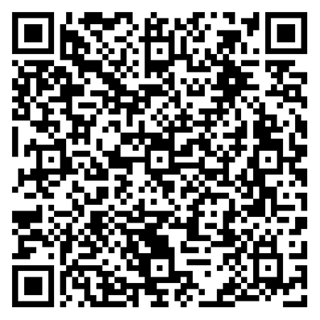
Payment to be made prior to arrival through
the online payment system by scanning
the QR code opposite. Once booking has been made,
please bring a copy of your payment receipt ‐ this
will be required in order to release the room
key upon your arrival.

Please return this form to
accommodation@uwtsd.ac.uk

